Announcements

Top of Form

* **All Assignments Posted**

Posted on: Monday, November 29, 2021 12:11:56 PM EST

Hello class,

Everything that's due from now until the end of class has been posted. (Any in-class assignments other than those listed will be bonus work.)

Included in these assignments are:

* + Module Six (Flask apps). These can be completed on repl.it and/or PythonAnywhere, depending on the assignment. This means that you don't have to deal with virtualenvironments.
  + Module Seven (Machine Learning) - the homework in this module is **for bonus credit** (it is optional).
  + Module Seven (Final Project) - This is the final version of whichever program you've been working on. For most students, this is the Text Adventure.

In addition to these assignments, I'll be accepting late assignments this week (11/29 - 12/3) with significantly reduced late penalties.

Thanks, and let's push through this last milestone for the semester!

Mr. Norris

Posted by: Andrew Norris

Posted to: 2021FA Advanced Python Programming (CSC-221-0001)

* **Assignment Videos**

Posted on: Monday, November 22, 2021 9:57:00 AM EST

The published links for M5T2 and M5T3 were accidentally set to private. I've confirmed these work now.

Here’s the links from the last two assignments (video, no sound)

M5t2 - <https://youtu.be/lthdhFK6I6c>

M5t3 - <https://youtu.be/yOos0WYSSW0>

Posted by: Andrew Norris

Posted to: 2021FA Advanced Python Programming (CSC-221-0001)

* **Assignments Updated**

Posted on: Wednesday, November 17, 2021 12:42:54 PM EST

Modules Six and Seven will be open shortly, and I've made some changes to Module Five.

The only required assignments from Module Five are the 3 tutorials. M5HW and M5PRO are now **optional, bonus** assignments.

The next upcoming assignments will be working with Flask in Module Six.

Posted by: Andrew Norris

Posted to: 2021FA Advanced Python Programming (CSC-221-0001)

* **M5T1**

Posted on: Wednesday, November 10, 2021 1:44:12 PM EST

M5T1 has been updated with a tutorial video (and a sample virtual environment, if you're having trouble setting yours up).

Course Link[/Assignments/Module Five/Homework and Projects/M5T1](https://faytechcc.blackboard.com/webapps/blackboard/content/launchLink.jsp?ann_id=_524349_1&course_id=_35059_1&mode=view)

Posted by: Andrew Norris

Posted to: 2021FA Advanced Python Programming (CSC-221-0001)

* **Module Five Now Open**

Posted on: Monday, November 8, 2021 11:39:21 AM EST

In Module Five we'll be covering some "special topics", libraries and code that have specific uses.

We'll start with NLP (Natural Language Processing) as described in Chapter 12.

Course Link[/Assignments/Module Five](https://faytechcc.blackboard.com/webapps/blackboard/content/launchLink.jsp?ann_id=_523721_1&course_id=_35059_1&mode=view)

Posted by: Andrew Norris

Posted to: 2021FA Advanced Python Programming (CSC-221-0001)

* **Another Python Text Adventure**

Posted on: Wednesday, November 3, 2021 2:05:43 PM EDT

Thanks to Mr. Brown for finding this one, this is a very extensively documented Python text adventure that has a fair bit in common with our system.

<https://github.com/jbussin/python-text-adventure>

Posted by: Andrew Norris

Posted to: 2021FA Advanced Python Programming (CSC-221-0001)

* **TextAdv_Python**

Posted on: Wednesday, November 3, 2021 2:03:34 PM EDT

Hello all,

Here's the current Github repo for the python version of the text adventure. You're welcome to use any of this code in your project, for example by subclassing existing classes or just modifying them.

<https://github.com/norrisaftcc/csc221/tree/master/textadv21>

Posted by: Andrew Norris

Posted to: 2021FA Advanced Python Programming (CSC-221-0001)

* **TextAdv_Cpp**

Posted on: Wednesday, October 27, 2021 7:52:47 PM EDT

so i'm rewriting our existing project in c++. (If you read Java or C#, you'l probably find this readable even if you have no C++ experience.)

You can find the example code for the upcoming Text Adventure project on GitHub in its own repo.

[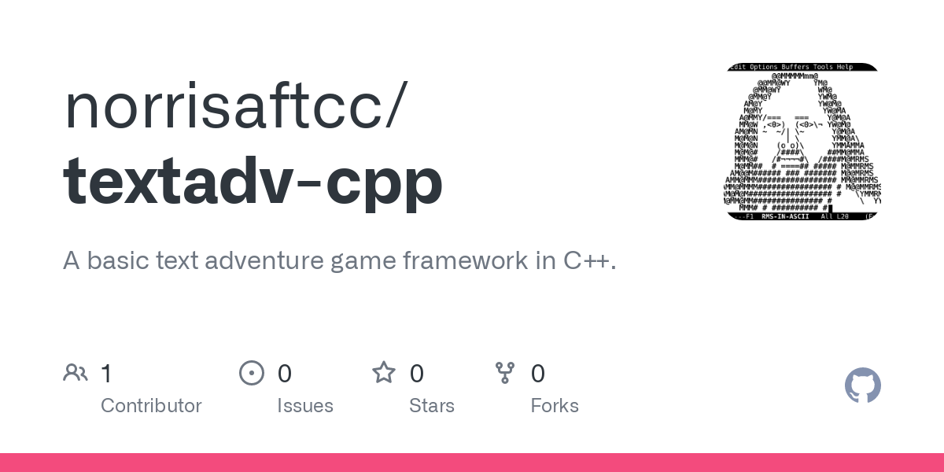GitHub - norrisaftcc/textadv-cpp: A basic text adventure game framework in C++.A basic text adventure game framework in C++. Contribute to norrisaftcc/textadv-cpp development by creating an account on GitHub.GitHub](https://github.com/norrisaftcc/textadv-cpp)

10/29 - This version is non-interactive. It's just a proof of concept for a program which can keep track of which room out of multiple rooms a player is in, and print the local description (such as what's in the room and what exits are present).

todo on this version compared to our python one is to add items and, oh yeah, an entire command parser.

Posted by: Andrew Norris

Posted to: 2021FA Advanced Python Programming (CSC-221-0001)

* **Friday Help Lab 10/29**

Posted on: Wednesday, October 27, 2021 11:28:01 AM EDT

I will be staffing the ATC 111 Friday Help Lab (10/29) this week. I'll be available from 9am - 3pm. Please feel free to drop by.

Posted by: Andrew Norris

Posted to: 2021FA Advanced Python Programming (CSC-221-0001)

* **Evennia Info**

Posted on: Monday, October 25, 2021 1:25:30 PM EDT

We're going to spend some time working with the Evennia library -- this is similar to the "engine" we started with, but with a lot more features.

[Evennia Python MUD/MU creation systemEvennia is a modern Python library and server for creating text-based multi-player games and virtual worlds (also known as MUD, MUSH, MU, MUX, MUCK, etc). While Evennia handles all the necessary things every online game needs, like database and networking, you create the game of your dreams by writing normal Python modules.](https://www.evennia.com/)

For now, try installing it using these directions: <https://www.evennia.com/docs/latest/Getting-Started.html>

(Note that virtualenv may have to be set up. It will still work without this, but it can make moving it to other machines more difficult.)

Course Link[/Assignments/Module Three/Evennia Info](https://faytechcc.blackboard.com/webapps/blackboard/content/launchLink.jsp?ann_id=_521418_1&course_id=_35059_1&mode=view)

Posted by: Andrew Norris

Posted to: 2021FA Advanced Python Programming (CSC-221-0001)

* **Module Three Now Open**

Posted on: Monday, September 20, 2021 11:46:12 AM EDT

Hello class,

In Module Three we'll be working in detail with classes and objects. Along the way we'll start to build our own Text Adventure using custom objects as needed.

Assignments M3T1, M3T2, and M3Proj are now available, and are due over the next few weeks. Additional assignments will be forthcoming.

Thanks, Mr. Norris

Course Link[/Assignments/Module Three](https://faytechcc.blackboard.com/webapps/blackboard/content/launchLink.jsp?ann_id=_512155_1&course_id=_35059_1&mode=view)

Posted by: Andrew Norris

Posted to: 2021FA Advanced Python Programming (CSC-221-0001)

* **First Meeting**

Posted on: Monday, August 16, 2021 10:12:27 AM EDT

Hello class, and welcome to CSC 221, Advanced Python Programming.

Our first meeting will be Monday, August 16, in ATC 156 at 1pm.

Posted by: Andrew Norris

Posted to: 2021FA Advanced Python Programming (CSC-221-0001)

* **Welcome**

Posted on: Wednesday, August 11, 2021 11:47:56 AM EDT

Welcome to **CSC 221, Advanced Python Programming.**I'm glad that you have decided to take this course.

To get started, click on **How Course Works** located in the navigation menu on the left. You will find instructions to help you get started in the course. Next view each of the navigation areas to get a feel for the structure of the course.

If you have any questions, don't hesitate to contact me. My contact information is listed in the **Instructor Information** area.

If you have difficulty accessing the information, activities, or services in this class, and/or need accommodations under the American with Disabilities Act, please contact Disability Support Services located in the Tony Rand Student Center, Room 127, or via phone at 910 678-8349.

Again, welcome aboard. By following the instructions and letting me know when you need help, you will be on the road for a successful online learning experience.

Posted by: Andrew Norris

Posted to: 2021FA Advanced Python Programming (CSC-221-0001)

Bottom of Form